|  |
| --- |
| **druse of emerald-green crystals of dioptase** |

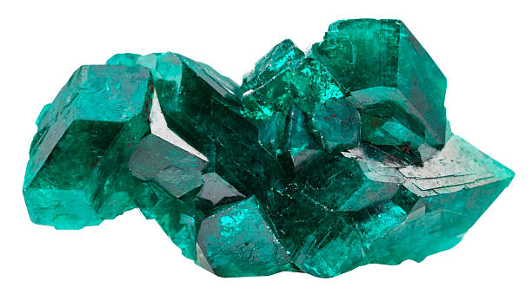

Dioptase is a strikingly beautiful copper silicate mineral that is known for its rich, emerald-green color. It is often found in the form of small, translucent crystals that form in a variety of arrangements. Here are some detailed aspects of dioptase: